Changes of pitcher and runs allowed

The situation becomes more complicated when there are one or more changes of pitcher. The rules state: When pitchers are changed during an inning, the official scorer shall not charge the relief pitcher with any run (earned or unearned) scored by a runner who was on base at the time such relief pitcher entered the game, nor for runs scored by any runner who reaches base on a fielder’s choice that puts out a runner left on base by any
preceding pitcher [OBR 9.16(g)].
Let us look more closely at this.
When there is a change of pitcher, any runners left on base are charged to the pitcher who put them on base, who is also charged with any runs they might score. Problems arise in the interpretation of the second part of the rule. The phrase is understood to refer to the actions of a runner (understood here to be the batter-runner) that lead to a preceding runner, who was put on base by the previous pitcher, being put out.
This can be seen more clearly in the following examples.
Example 25: The starting pitcher leaves one runner on base when he is relieved. The next batter hits a single to right field and the previous runner scores.
As a rule, to which there are no exceptions, the runners left on base by a pitcher belong to the starting pitcher.
For this reason, the run is charged to the first pitcher.
WBSC |  | Traduction dans l’outil de scorage |  | Outil
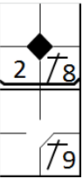 |  | /* le batteur frappe un simple dans le champ centre */  action { batter -> 1B8 }  /* Remplacement du lanceur */  substitution hometeam {  player 1 replaceBy "CAMBUZAT Valerian" shirtNumber=32 at 1  }  /* Le batteur frappe un simple dans le champ droit, le coureur marque */  action { batter -> 1B9 , runner1 -> +++ earned } |  | 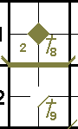

Example 26: The first pitcher leaves one runner on base, and he is put out after the pitcher is relieved by a normal action as a result of a batted ball.
Given that the first pitcher left one runner on base, he must be charged with a run.
We have here the two fundamental conditions: an occupied ball and the putout of a runner put on base by the first pitcher.
The run is therefore charged to the first pitcher.
WBSC |  | Traduction dans l’outil de scorage |  | Outil
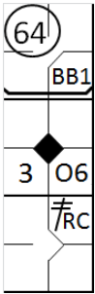 |  | /* Le batteur arrive sur base sur un 'base on ball' */  action { batter -> BB }  /* Remplacement du lanceur */  substitution hometeam {  player 1 replaceBy "CAMBUZAT Valerian" shirtNumber=32 at 1  }  /* Le batteur frappe une sur l'arrêt qui fait le choix de retirer le coureur' */  action { batter -> O6 , runner1 -> 64 }  /* Le batteur frappe un double dans le champ droit */  action { batter -> 2BRC , runner1 -> +++ earned } |  | 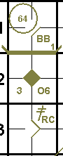

Example 27: In this example, the second baseman failed to put out the runner.
As the second run cannot be charged to the first pitcher, as he would in that case be charged with two runs, despite having left only one runner on base, the fielding chance (6E4) is transferred to the second pitcher (in place of the ‘O6’).
The first run is therefore earned and the second is unearned.
WBSC |  | Traduction dans l’outil de scorage |  | Outil
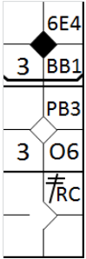 |  | /* Le batteur arrive sur base sur un 'base on ball' */  action { batter -> BB }  /* Remplacement du lanceur */  substitution hometeam {  player 1 replaceBy "CAMBUZAT Valerian" shirtNumber=32 at 1  }  /* Le batteur frappe une sur l'arrêt qui fait le choix de retirer le coureur' */  action { batter -> O6 , runner1 -> 6E4 }  /* Le batteur frappe un double dans le champ droit */  action { batter -> 2BRC , runner1 -> +++ , runner2 -> ++ earned } |  | 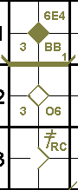

Example 28: The first pitcher leaves one runner on base.
The runner is picked off base, i.e. the putout is not due to an action by the batter.
The first pitcher is therefore not charged with any runs, and the run is consequently charged to the relief pitcher.
WBSC |  | Traduction dans l’outil de scorage |  | Outil
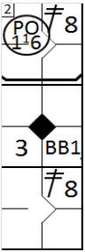 |  | /* Le batteur frappe un double dans le champ centre */  action { batter -> 2B8 }  /* Remplacement du lanceur */  substitution hometeam {  player 1 replaceBy "CAMBUZAT Valerian" shirtNumber=32 at 1  }  /* Le batteur suivant gagne la première base sur un 'base on ball' */  action { batter -> BB }  /* Le coureur en deux est retiré sur un pick off */  action { runner2 -> PO16 }  /* Le batteur frappe un double dans le champ droit, le couteur marque */  action { batter -> 2B8 , runner1 -> +++ earned } |  | 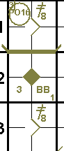

Example 29: The first pitcher leaves one runner on base, who is subsequently put out trying to advance on a hit.
The author of the hit reaches second and subsequently scores.
The run is charged to the second pitcher as the runner put on base by the first pitcher was put out by his own fault and not by the fault of the batter.
WBSC |  | Traduction dans l’outil de scorage |  | Outil
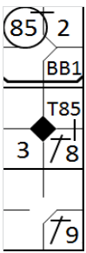 |  | /* Le batteur arrive sur base sur un 'base on ball' */  action { batter -> BB }  /* Remplacement du lanceur */  substitution hometeam {  player 1 replaceBy "CAMBUZAT Valerian" shirtNumber=32 at 1  }  /* Le batteur frappe un simple dans le champ centre et profite d'une relai du 8 pour gagner la deuxième */  action { batter -> 1B8 T85 , runner1 -> + 85 }  /* Le batteur frappe un simple dans le champ droit et le coureur marque un point */  action { batter -> 1B9 , runner2 -> ++ earned } |  | 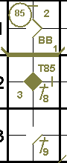

Example 30: The first and second pitchers both leave one runner on base when they are relieved, and must therefore be charged with one run each.
The first runner is put out on a batted ball, likewise the second, while the batter-runners reach base safely on an occupied ball.
The fifth batter hits a home run to the right field.
A run is charged to each pitcher.
WBSC |  | Traduction dans l’outil de scorage |  | Outil
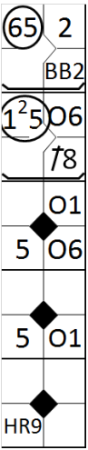 |  | /* Le batteur arrive sur base sur un 'base on ball' */  action { batter -> BB }  /* Remplacement du lanceur */  substitution hometeam {  player 1 replaceBy "CAMBUZAT Valerian" shirtNumber=32 at 1  }  /* Le batteur frappe un simple dans le champ centre, le coureur avance */  action { batter -> 1B8 , runner1 -> + }  /* Remplacement du lanceur */  substitution hometeam {  player 1 replaceBy "POTIER Nicolas" shirtNumber=32 at 1  }  /* Le batteur frappe une balle sur l'arrêt court qui fait le choix de retirer le premier coureur */  action { batter -> O6 , runner1 -> O6 , runner2 -> 65 }  /* Le batteur frappe une balle sur le laceur qui fait le choix de retirer le premier coureur */  action { batter -> O1 , runner1 -> O1 , runner2 -> 15 }  /* le batteur frappe un home run, tout le monde marque un point */  action { batter -> HR9 earned, runner1 -> +++ earned, runner2 -> ++ earned } |  | 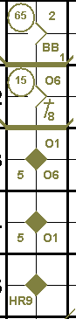

Example 31: The first pitcher leaves one runner on base.
He must be charged with one run.
During the play in which the runner put on base by the first pitcher is put out, the other runners reach base safely because the ball is occupied.
Two runs are then scored.
The first run is charged to the first pitcher, while the second is charged to the second pitcher.
Indeed, the first pitcher may be charged with only one run as he left only one man on base.
WBSC |  | Traduction dans l’outil de scorage |  | Outil
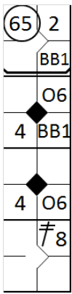 |  | /* Le batteur arrive sur base sur un 'base on ball' */  action { batter -> BB }  /* Remplacement du lanceur */  substitution hometeam {  player 1 replaceBy "CAMBUZAT Valerian" shirtNumber=32 at 1  }  /* Le batteur arrive sur base sur un 'base on ball', le coureur avance */  action { batter -> BB, runner1 -> + }  /* Le batteur frappe une balle vers l'arrêt court qui fait le choix de retirer le coureur le plus avancé */  action { batter -> O6 , runner1 -> O6 , runner2 -> 65 }  /* Le batteur frappe une balle dans le champ centre, les deux coureur rentre */  action { batter -> 2B8 , runner1 -> +++ earned, runner2 -> ++ earned } |  | 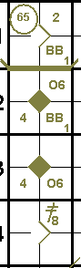
Comment: It is the intent of Rule 9.16(g) to charge each pitcher with the number of runners he put on base, rather than with the individual runners. When a pitcher puts runners on base, and is relieved, such pitcher shall be charged with all runs subsequently scored up to and including the number of runners such pitcher left on base when such pitcher left the game, unless such runners are put out without action by the batter,( i.e. caught stealing, picked off base, or called out for interference when a batter-runner does not reach first base on the play [OBR 9.16(g)].
Example 32: Both the first and second pitchers leave one runner on base.
The runner on first base, who was put there by the second pitcher, is put out on a ground ball by the third batter.
The preceding runner is put out on a batted ball by the fourth batter.
The next home run hit brings in three runs, all earned.
Each pitcher is charged with one run.
WBSC |  | Traduction dans l’outil de scorage |  | Outil
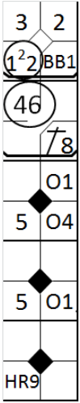 |  | /* Le batteur arrive sur base sur un 'base on ball' */  action { batter -> BB }  /* Remplacement du lanceur */  substitution hometeam {  player 1 replaceBy "CAMBUZAT Valerian" shirtNumber=32 at 1  }  /* Le batteur frappe un simple dans le champ centre, le coureur avance */  action { batter -> 1B8 , runner1 -> + }  /* Remplacement du lanceur */  substitution hometeam {  player 1 replaceBy "POTIER Nicolas" shirtNumber=32 at 1  }  /* Le batteur frappe une balle sur la deuxième base qui fait le choix de retirer le premier coureur */  action { batter -> O4 , runner1 -> 46 , runner2 -> + }  /* Le batteur frappe une balle sur le laceur qui fait le choix de retirer le coureur qui arrive au marbre */  action { batter -> O1 , runner1 -> O1 , runner3 -> 12 }  /* le batteur frappe un home run, tout le monde marque un point */  action { batter -> HR9 earned, runner1 -> +++ earned, runner2 -> ++ earned } |  | 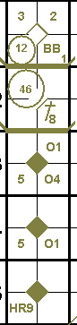

Example 33: The first pitcher leaves one runner on base when he is substituted. The batter on the second pitcher is put out. A third pitcher climbs the mound. The first runner is put out on a batted ball, while the batter-runner reaches base safely on an occupied ball. The fourth batter hits a home run to the right field.
An earned run is charged to the first and the third pitcher.
WBSC |  | Traduction dans l’outil de scorage |  | Outil
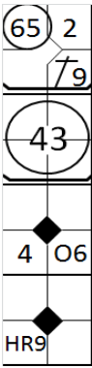 |  | /* Le batteur frappe un simple dans le champ droit */  action { batter -> 1B9 }  /* Remplacement du lanceur */  substitution hometeam {  player 1 replaceBy "CAMBUZAT Valerian" shirtNumber=32 at 1  }  /* Le batteur frappe est retiré sur une bale au sol, le coureur avance */  action { batter -> 43 , runner1 -> + }  /* Remplacement du lanceur */  substitution hometeam {  player 1 replaceBy "POTIER Nicolas" shirtNumber=32 at 1  }  /* le batteur frappe un balle vers l'arrêt court qui fait un choix défensif en retirant le coureur */  action { batter -> O6 , runner2 -> 65 }  /* le batteur frappe un home runn */  action { batter -> HR9 earned , runner1 -> +++ earned } |  | 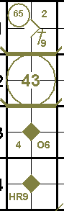
The OBR states in rule 9.16(i) that when pitchers are changed during an inning, the relief pitcher shall not have the benefit of previous chances for outs not accepted in determining earned runs.
Rule 9.16(i) Comment: It is the intent of Rule 9.16(i) to charge a relief pitcher with earned runs for which such relief pitcher is solely responsible. In some instances, runs charged as earned against the relief pitcher can be charged as unearned against the team.
To clarify the meaning of this note, let us look at the following example:
Example 34: The first batter hits a fly ball and is put out by the left fielder.
The next batter reaches second base safely on a catching error by the center fielder.
The third batter hits a single to the right field, sending the runner to third base.
The fourth batter hits a sacrifice fly that enables the runner on third to score the first run (the runner on first base stays put).
After a pitching change, the fifth batter hits a home run that brings in two runs.
The first pitcher is charged with two unearned runs (there had been three fielding chances at the time the home run was hit: ‘F7’, ‘E8F’ and ‘SF8’).
The second pitcher is charged with one earned run (only two fielding chances were transferred by the previous pitcher: ‘F7’ and ‘SF8’).
WBSC |  | Traduction dans l’outil de scorage |  | Outil
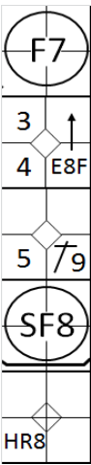 |  | /* Le batteur est retiré sur un fly dans le champ gauche */  action { batter -> F7 }  /* Le batteur arrive sur base sur une erreur du champ centre et profite de l'erreur pour prendre la deuxième base */  action { batter -> E8F+ }  /* Le batteur frappe un simple dans le champ droit, le coureur avance d'une base */  action { batter -> 1B9 , runner2 -> + }  /* le batteur frappe un sacrifice fly, le coureur marque le point */  action { batter -> SF8 , runner3 -> + }  /* Remplacement du lanceur */  substitution hometeam {  player 1 replaceBy "CAMBUZAT Valerian" shirtNumber=32 at 1  }  /* le batteur frappe un home run, deux points sont marqués */  action { batter -> HR8 unEarnedForTeam , runner1 -> +++ } |  | 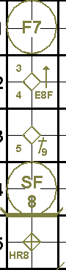
The team is charged with three runs, none of which is earned, as the team had three fielding chances: ‘F7’, ‘E8F’ and ‘SF8’.
This example shows that the third run is a run unearned against the team, but earned against the pitcher.
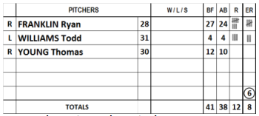 | Example 35: Evidently, when a situation such as that described above occurs during the course of a game, the total number of runs earned against the team will be less than the total number of runs earned against the pitchers.
In order to make this clear, the number of runs earned against the team must be circled.
ATTENTION: In the cumulative totals compiled at the end of each half inning, the total runs earned against the pitcher, including those unearned against the team, are recorded.
Example 36: With two out, i.e. with two fielding chances, there is a base on balls followed by an error.
This error constitutes the third fielding chance for the first pitcher, who therefore cannot be charged with any further earned runs.
The relief pitcher, on the other hand, does not benefit from the failed putout.
Consequently, the home run, which is charged to the relief pitcher, is earned against the pitcher but unearned against the team.
WBSC |  | Traduction dans l’outil de scorage |  | Outil
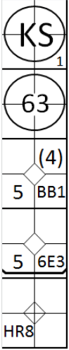 |  | /* Le batteur est strike out */  action { batter -> KS }  /* Le batteur est retiré sur une frappe au sol */  action { batter -> 63 }  /* Le batteur arrive sur base sur un 'base on ball' */  action { batter -> BB }  /* Le batteur arrive sur une erreur de réception du première base, le coureur avance sur l'erreur */  action { batter -> 6E3 , runner1 -> (4) }  /* Remplacement du lanceur */  substitution hometeam {  player 1 replaceBy "CAMBUZAT Valerian" shirtNumber=32 at 1  }  /* Le batteur frappe un home run */  action { batter -> HR8 unEarnedForTeam, runner1 -> +++ , runner2 -> ++ } |  | 

Example 37: With two out, there follow two bases on balls, after which the pitcher is relieved. An error is committed against the next batter.
This error constitutes the third fielding chance for the relief pitcher, who can also count the two putouts.
But it is also the third fielding chance for the first pitcher, as the relief pitcher cannot count failed putouts, although the replaced pitcher can.
From this moment, therefore, no runs charged to either the first or the second pitcher can be earned.
Thus, with the subsequent home run, two runs are charged to the first pitcher and two to the second, although none are earned.
WBSC |  | Traduction dans l’outil de scorage |  | Outil
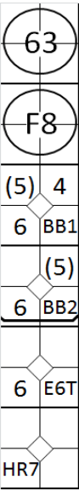 |  | /* le batteur est retiré sur une frappe au sol */  action { batter -> 63 }  /* le batteur est retiré sur un fly dans le champ centre */  action { batter -> F8 }  /* Le batteur arrive sur base sur 'base on ball' */  action { batter -> BB }  /* Le batteur arrive sur base sur 'base on ball, le coureur avance */  action { batter -> BB, runner1 -> + }  /* Remplacement du lanceur */  substitution hometeam {  player 1 replaceBy "CAMBUZAT Valerian" shirtNumber=32 at 1  }  /* Le batteur arrive sur base sur une erreur de relance du 6, les deux coureurs avancent sur l'erreur */  action { batter -> E6T , runner1 ->(5) , runner2 ->(5) }  /* Le batteur frappe un home run, tous les coureur rentre */  action { batter -> HR7, runner1 -> +++, runner2 -> ++, runner3 -> + } |  | 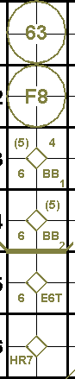

Example 38: In this inning, after a putout, with the batter runner on first base because of an error, the third batter is awarded a base on balls.
The fourth batter reaches first base safely on a fielder’s choice, as on the hit the pitcher tried unsuccessfully to put out the runner heading for second.
Bearing in mind that fielder’s choice is not a fielding chance, the runs by the third, fourth and fifth batters are earned runs, both for the team and the relief pitchers, because team and pitchers only have two and one fielding chances respectively at this moment.
WBSC |  | Traduction dans l’outil de scorage |  | Outil
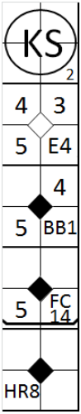 |  | /* Le batteur est strike out */  action { batter -> KS }  /* Le batteur suivant arrive sur base sur une erreur de deuxième base */  action { batter -> E4 }  /* Le batteur arrive sur base sur un 'base on ball' */  action { batter -> BB , runner1 -> + }  /* le batteur arrive sur base sur un choix défensif */  action { batter -> FC14 , runner1 -> + , runner2 -> + }  /* Remplacement du lanceur */  substitution hometeam {  player 1 replaceBy "CAMBUZAT Valerian" shirtNumber=32 at 1  }  /* Le batteur frappe un home run */  action { batter -> HR8 earned, runner1 -> +++ earned , runner2 -> ++ earned , runner3 -> + } |  | 

Example 39: In this inning, after a base on balls, there is an error, which constitutes the first and only fielding chance for the first pitcher, who is then relieved.
The relief pitcher therefore begins with no fielding chances to his credit.
He gives up a three-run home run: the first two runs are charged to the first pitcher, and only the first is earned, as the second was compromised by an error.
The home run itself is charged to the second pitcher, and is an earned run.
The inning continues with two strikeouts, after which there is another error.
This is the third fielding chance for the second pitcher, and thus no runs charged against him from this moment on are earned.
WBSC |  | Traduction dans l’outil de scorage |  | Outil
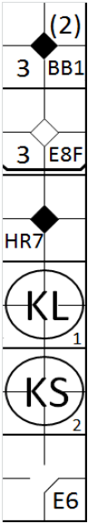 |  | /* Le batteur arrive sur base sur un 'base on ball' */  action { batter -> BB }  /* Le batteur arrive sur base sur une erreur de rattrapé de fly */  action { batter -> E8F , runner1 -> (2) }  /* Remplacement du lanceur */  substitution hometeam {  player 1 replaceBy "CAMBUZAT Valerian" shirtNumber=32 at 1  }  /* Le batteur frappe un home run */  action { batter -> HR7 earned, runner1 -> +++ , runner2 -> ++ earned }  /* Le batteur est strike out */  action { batter -> KL }  /* le batteur est strike out */  action { batter -> KS }  /* le batteur arrive sur base sur une erreur de l'arrêt court */  action { batter -> E6 } |  | 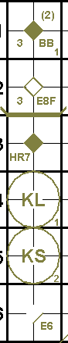

Example 40: The first batter reaches first base on an error.
The pitcher is replaced.
The second batter is awarded a base on balls and the third hits a ground ball to the shortstop who assists the third baseman in putting out the lead runner, while the others reach base safely.
Finally, the fourth batter hits a safe hit, sending the second runner home.
The run is charged to the first pitcher but is not earned because of the batter reaching first base on the error.
When, after a pitcher change, a batted ball results in a putout of a runner, both for the batter as well as any other runner an occupied shall be written.
WBSC |  | Traduction dans l’outil de scorage |  | Outil
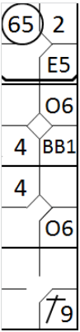 |  | /* Le batteur arrive sur base sur une erreur du défenseur de la troisième base */  action { batter -> E5 }  /* Remplacement du lanceur */  substitution hometeam {  player 1 replaceBy "CAMBUZAT Valerian" shirtNumber=32 at 1  }  /* le batteur arrive sur base sur un 'base on ball' */  action { batter -> BB, runner1 -> + }  /* Le batteur arrive sur base sur un choix défensif de l'arrêt court */  action { batter -> O6, runner1 -> O6 , runner2 -> 65 }  /* Le batteur frappe un simple dans le champ droit */  action { batter -> 1B9, runner1 -> ++ , runner2 -> ++ } |  | 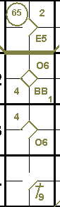
Especially in cases like this one, we have to keep in mind that the relief pitcher cannot be charged with any run (earned or unearned) scored by a runner who was on base at the time such relief pitcher entered the game [OBR 9.16(g)]. Instead the first pitcher must be charged with the number of runners he put on base, rather than with the individual runners.
Example 41: The first batter reaches first base on an error.
The second is awarded a base on balls and the pitcher is replaced.
The third batter hits a safe hit, filling the bases.
The fourth batter hits a ground ball to the third baseman who throws an assist to home base, putting out the first runner.
The fifth batter hits a ground ball to shortstop who throws an assist to home base, putting out the second runner.
The sixth batter hits a four-run home run, and the inning finally ends with the seventh batter being struck out.
The first pitcher should be charged with two runs, as he was replaced with two men on base.
The runs in question are the first two, and they are indicated by the occupied ball notation.
WBSC |  | Traduction dans l’outil de scorage |  | Outil
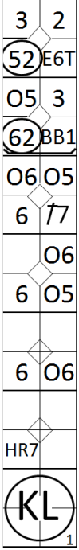 |  | /* le batteur arrive sur base sur une erreur de lancer de l'arrêt court */  action { batter -> E6T }  /* Le batteur arrive sur base sur un 'base on ball' */  action { batter -> BB, runner1 -> + }  /* Remplacement du lanceur */  substitution hometeam {  player 1 replaceBy "CAMBUZAT Valerian" shirtNumber=32 at 1  }  /* Le batteur frappe un simple dans le champ gauche */  action { batter -> 1B7 , runner1 -> + , runner2 -> + }  /* Le batteur suivant arrive sur base sur un choix défensif */  action { batter -> O5, runner1 -> O5 , runner2 -> O5 , runner3 -> 52 }  /* Le batteur suivant arrive sur base sur un choix défensif */  action { batter -> O6, runner1 -> O6 , runner2 -> O6 , runner3 -> 62 }  /* Le batteur suivant frappe un home run */  action { batter -> HR7 unEarnedForTeam , runner1 -> +++ unEarnedForTeam , runner2 -> ++ , runner3 -> + }  /* Le batteur suivant est retiré sur strike out */  action { batter -> KL } |  | 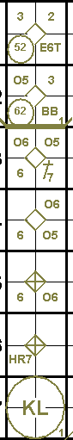
Neither of these, however, is earned, as for the first a fielding chance was transferred from the first batter, and with the second run there had already been three fielding chances.
The other two runs are charged to the second pitcher, and they are earned against the pitcher but not against the team, since the pitcher had amassed only two fielding chances.
As far as fielding chances are concerned, it should be noted that in the event of an attempted double play, there are two opportunities in the same action, with either two putouts, or a putout and an error.
However, if just one putout is made, and the other attempted putout is unsuccessful, but not because of an error, only one fielding chance has occurred.
To conclude this chapter on earned runs, we shall look a little more closely at the issue of legal and illegal advances.
A base runner is not static but he can make a play. When a runner should not have been on base, or should not have advanced to that point (because of an error or a passed ball), no account must be taken of any plays made by him for the purposes of calculating earned runs.
Example 42: The runner on second base would not have been able to advance if the game had been played correctly, so for the purposes of calculating earned runs he should be considered as being on first base.
WBSC |  | Traduction dans l’outil de scorage |  | Outil
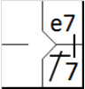 |  | /* le batteur frappe un simple dans le champ gauche et profite de l'erreur pour gagner une base supplémentaire */  action { batter -> 1B7 e7 } |  | 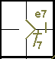

Example 43: The first batter hits to the right field and, thanks to an error by the outfielder, reaches third base. The second batter walks and goes on to steal second base. The third batter hits to the left field, enabling both runners to score.
Up to this moment, the first run is earned, but not the second, since if it had not been for the outfielder’s error, the lead runner would have remained on second base, thus removing from the other runner any possibility of stealing, and the third batter’s safe hit would have sent home only the first runner, while the second runner would have stopped at third base.
WBSC |  | Traduction dans l’outil de scorage |  | Outil
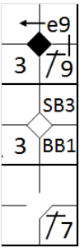 |  | /* le batteur frappe un simple dans le champ droit et profite de l'erreur pour gagner deux bases supplémentaires */  action { batter -> 1B9 e9+ }  /* Le batteur arrive sur base sur un 'base on ball' */  action { batter -> BB }  /* Le coureur en 1 vole la base */  action { runner1 -> SB }  /* Le batteur frappe une simple dans le champ gauche, les deux coureurs marquent */  action { batter -> 1B7 , runner2 -> ++ , runner3 -> + earned } |  | 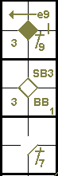

Example 44: The first batter is awarded a base on balls and reaches second base on an error when the first baseman attempts to pick him off. The second batter reaches first on a wild pitch after having swung at the third strike, and the runner reaches third base. The third batter hits a home run. The first and third runs are earned, but not the second, because if it had not been for the fielding error on the first runner, first base was occupied and the second batter would have been called out under rule 5.09(a)(3) of the OBR.
WBSC |  | Traduction dans l’outil de scorage |  | Outil
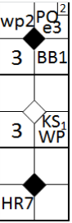 |  | /* Le batteur gagne la première base sur un 'base on ball' */  action { batter -> BB }  /* Le coureur gagne la deuxième base sur 'pick off' raté */  action { runner1 -> PO1e3 }  /* Le batteur arrive sur base sur un troisième strike relaché */  action { batter -> KSWP , runner2 -> wp }  /* Le batteur frappe un home run */  action { batter -> HR7 earned , runner1 -> +++ , runner3 -> + earned } |  | 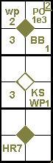
IMPORTANT: From the two previous examples it can be seen that an illegal advance by a previous runner can affect the legality of a subsequent action.
Example 45: With a man on second base due to an error, a safe hit to the center fielder enables him to score, while the batter runner reaches second base on the throw to home base.
If the play had been legal, the first runner would not have been where he was, so the center fielder would not have thrown to home base and the batter would have remained on first base.
On the next hit another run is scored, which for the time being is unearned since the runner, after having advanced two bases, would have been on third base.
We therefore recommend reconstructing the action carefully to determine whether an advance is legal or not. In this respect it can be helpful to reconstruct an imaginary inning, only with legal advances, excluding all advances because of errors or passed balls.
WBSC |  | Traduction dans l’outil de scorage |  | Outil
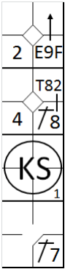 |  | /* Le batteur arrive sur base sur une erreur sur une fly et profite de l'erreur pour gagner une base supplémentaire */  action { batter -> E9F+ }  /* le batteur frappe un simple dans le champ centre et profite du relai pour gagner la 2, le coureur marque */  action { batter -> 1B8 T82 , runner2 -> ++ }  /* Le batteur suivant est strike out */  action { batter -> KS }  /* Le batteur frappe un simple dans le champ gauche, le coureur marque */  action { batter -> 1B7 , runner2 -> ++ } |  | 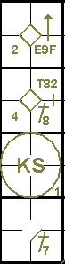

Example 46: In this situation we see the action as it occurred. We have an indication of what would have happened with legal play: the second batter would not yet have scored, but would have stopped at third base.
With this method it is possible to see clearly that if a runner had scored through legal play, the corresponding run in the real action would be earned, even if the play had been illegal. If not, a run actually scored would be unearned.
WBSC |  | Traduction dans l’outil de scorage |  | Outil
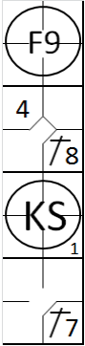 |  | /* Le batteur est retiré sur une fly */  action { batter -> F9 }  /* Le batteur frappe un simple dans le champ centre */  action { batter -> 1B8 }  /* Le batteur est strike out */  action { batter -> KS }  /* Le batteur frappe un strike dans le champ gauche */  action { batter -> 1B7, runner1 -> ++ } |  | 

Example 47: With a runner on first base, the first baseman muffs a foul fly on an easy hit and an error is therefore noted in the first base square.
The second batter hits a home run.
The second run cannot be earned in any circumstances.
In order to determine whether the first run is earned, we have to wait for the subsequent turns at bat, as in the reconstruction of the inning the first batsman should be considered as being still on first base.
WBSC |  | Traduction dans l’outil de scorage |  | Outil
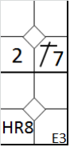 |  | /* Le batteur frappe un simple dans le champ gauche */  action { batter -> 1B7 }  /* Le batteur aurait du être retiré sur une fly dans les fausses balles */  action { batter -> EF3 }  /* La batteur frappe un home run dans le champ centre */  action { batter -> HR8 , runner1 -> +++ } |  | 